1. **A Soft Murmur - William**

URL of website: <https://asoftmurmur.com/>

I chose this website because there’s a lot of interactions that can be done with the website and when I first saw it, I could already spot some parts of the website that I could break down and code. The thing that stood out to me was the ability to change the volume of multiple items simultaneously, though I don’t know how to do that yet.

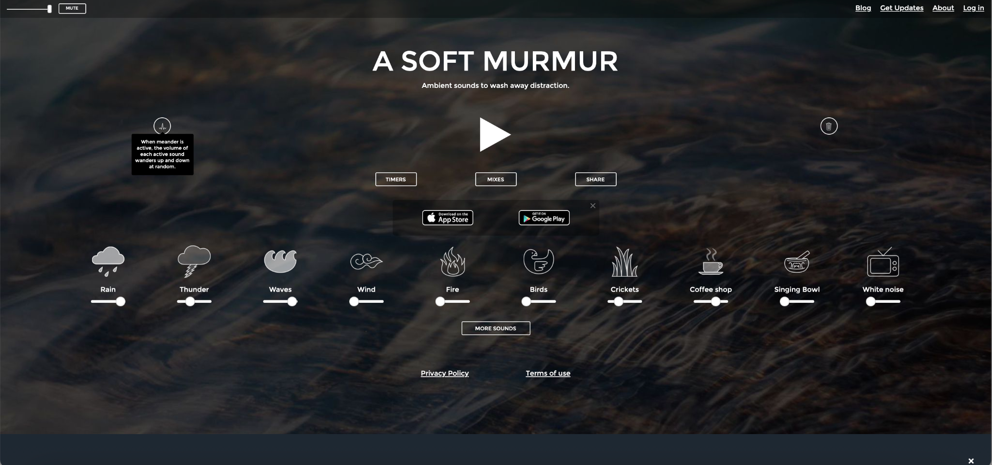

Breakdown of the website:

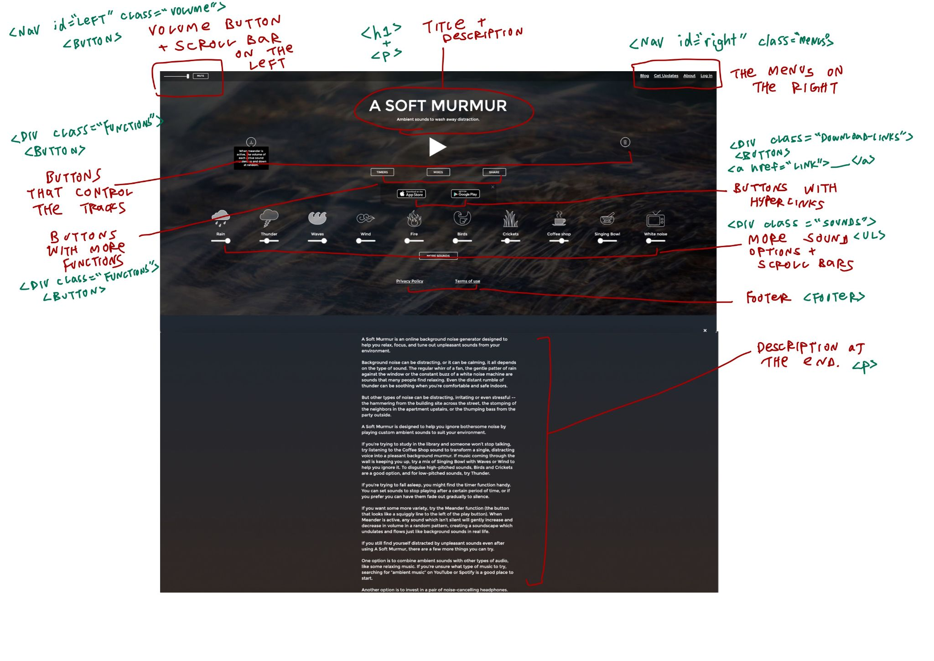

Code:

<!DOCTYPE html>

<html>

<head>

<meta charset="UTF-8">

<title>A Soft Murmur</title>

</head>

<body>

<div id="left" class="volume">

</div>

<h1>A Soft Murmur</h1>

<p>Ambient sounds to wash away distraction.</p>

<nav id="right" class="menu">

<ul>

<li>Blog</li>

<li>Get Updates</li>

<li>About</li>

<li>Log in</li>

</ul>

</nav>

<div class="commands">

<button>meander</button>

<button>play</button>

<button>delete</button>

</div>

<div class="functions">

<button>TIMERS</button>

<button>MIXES</button>

<button>SHARE</button>

<button>MORE SOUNDS</button>

</div>

<div class="download-links">

<button><a href="https://apps.apple.com/app/apple-store/id1175522255?ct=&pt=118464987">app store</a></button>

<button><a href="https://play.google.com/store/apps/details?id=com.gabemart.asoftmurmur">google play</a></button>

</div>

<div class="sounds">

<ul>

<li>Rain</li>

<li>Thunder</li>

<li>Waves</li>

<li>Wind</li>

<li>Fire</li>

<li>Birds</li>

<li>Crickets</li>

<li>Coffee shop</li>

<li>Singing Bowl</li>

<li>White noise</li>

</ul>

</div>

<footer>

<ul>

<li>Privacy Policy</li>

<li>Terms of use</li>

</ul>

</footer>

<p>A Soft Murmur is an online background noise generator designed to help you relax, focus, and tune out unpleasant sounds from your environment.

Background noise can be distracting, or it can be calming, it all depends on the type of sound. The regular whirr of a fan, the gentle patter of rain against the window or the constant buzz of a white noise machine are sounds that many people find relaxing. Even the distant rumble of thunder can be soothing when you’re comfortable and safe indoors.

But other types of noise can be distracting, irritating or even stressful -- the hammering from the building site across the street, the stomping of the neighbors in the apartment upstairs, or the thumping bass from the party outside.

A Soft Murmur is designed to help you ignore bothersome noise by playing custom ambient sounds to suit your environment.

If you’re trying to study in the library and someone won’t stop talking, try listening to the Coffee Shop sound to transform a single, distracting voice into a pleasant background murmur. If music coming through the wall is keeping you up, try a mix of Singing Bowl with Waves or Wind to help you ignore it. To disguise high-pitched sounds, Birds and Crickets are a good option, and for low-pitched sounds, try Thunder.

If you’re trying to fall asleep, you might find the timer function handy. You can set sounds to stop playing after a certain period of time, or if you prefer you can have them fade out gradually to silence.

If you want some more variety, try the Meander function (the button that looks like a squiggly line to the left of the play button). When Meander is active, any sound which isn’t silent will gently increase and decrease in volume in a random pattern, creating a soundscape which undulates and flows just like background sounds in real life.

If you still find yourself distracted by unpleasant sounds even after using A Soft Murmur, there are a few more things you can try.

One option is to combine ambient sounds with other types of audio, like some relaxing music. If you’re unsure what type of music to try, searching for “ambient music” on YouTube or Spotify is a good place to start.

Another option is to invest in a pair of noise-cancelling headphones. However, while noise cancellation technology tends to be pretty effective against steady, predictable noise sources, like the sound of travelling in a plane or train, it’s much less effective against more random, intermittent noise, like construction work or emergency sirens.

Finally, when all else fails you can try a pair of earplugs. But again, these tend to work well for some frequencies of sounds and less well for others. In a previous apartment I lived above neighbours who liked to party til 6am all days of the week. I would sometimes wear earplugs, then put my over-ear noise-cancelling headphones on top playing ambient music and nature sounds. It’s amazing what the mind comes up with when you really, really need to sleep.

I hope A Soft Murmur is enjoyable and useful for you. If you have any questions, comments or complaints, please send me a message at gabriel@asoftmurmur.com

I hope you have a relaxing day!

-- Gabriel</p>

</body>

</html>

**2. Fix-Nothing - Yejin**

URL of website: <https://www.fixnothing.com/us/main/index.php>

I chose this website because it has a basic structure like a menu bar and buttons on every website, but it has a lot of new interactive elements. Also, I thought it would be possible to apply it in various ways to learn this structure, and if I could make a website by myself later, I wish I can make it interactive.

**- Website Screenshot -**

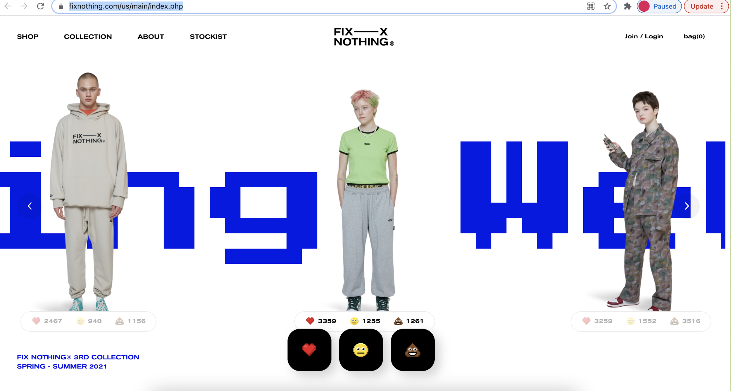

**- Website Breakdown -**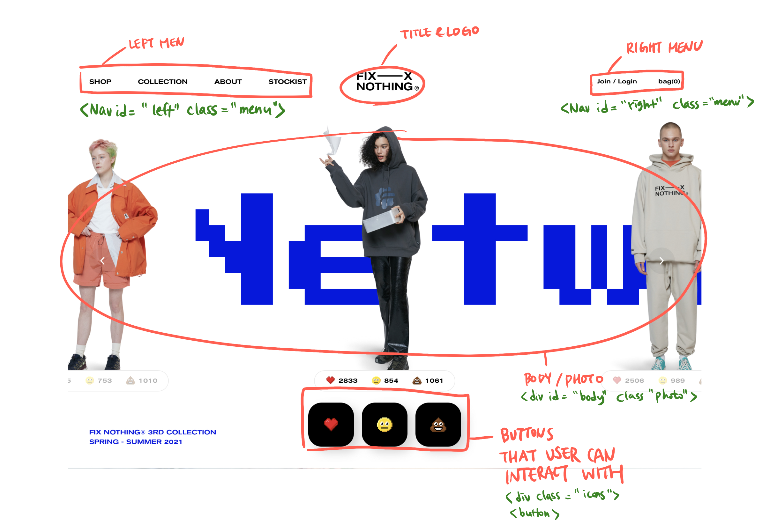

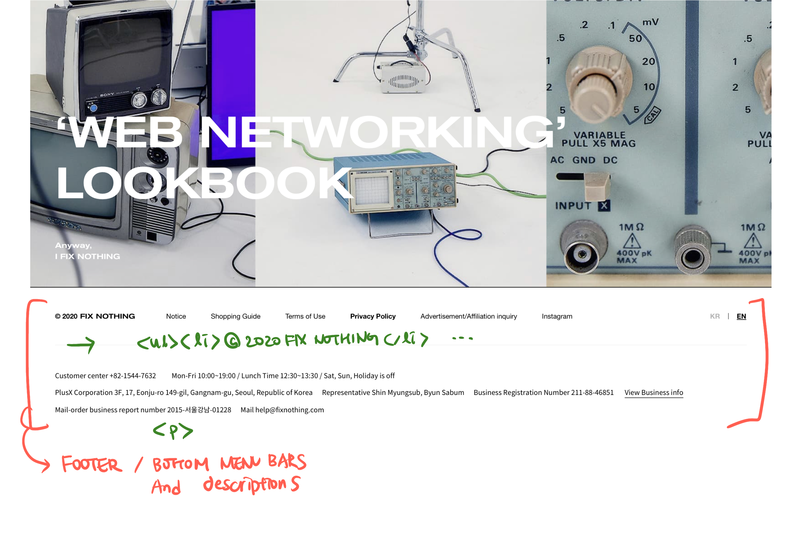

**-Structure Code-**

<!DOCTYPE html>

<!-- The website this is a structural break down can be found at: www.fixnothing.com -->

<html>

<head>

<meta charset="UTF-8">

<title>FIX NOTHING</title>

<h1>FIX NOTHING</h1>

</head>

<body>

<div id="center" class="logo">

<img src=" ">

</div>

<nav id="left" class="menu">

<ul>

<li>SHOP</li>

<li>COLLECTION</li>

<li>ABOUT</li>

<li>STOCKIST</li>

</ul>

<nav id="right" class="menu">

<ul>

<li>Join/Login</li>

<li>Bag</li>

</ul>

</nav>

<div id="body" class="photo">

<img src="">

</div>

</nav>

<div class="icons">

<button>heart</button>

<button>smile</button>

<button>poo</button>

</div>

</nav>

<footer>

<ul>

<li>© 2020 FIX NOTHING</li>

<li>Notice</li>

<li>Shopping Guide</li>

<li>Term of Use</li>

<li><b>Privacy Policy</b></li>

<li>Advertisement/Affiliation inquiry</li>

<li><a href="https://www.instagram.com/fixnothing.official/">Instagram</a></li>

<p>

Customer center +82-1544-7632<br>

Mon-Fri 10:00~19:00 /Lunch Time 12:30~13:30 / Sat, Sun, Holiday is off <br>

PlusX Corporation 3F, 17, Eonju-ro 149-gil, Gangnam-gu, Seoul, Republic of Korea <br>

Representative Shin Myungsub, Byun Sabum<br>

Business Registration Number 211-88-46851 <br>

View Business info<br>

Mail-order business report number 2015-서울강남-01228<br>Mail help@fixnothing.com

</p>

</ul>

</footer>

</body>

</html>